Refresher: hackathon plan and team split
Oct 18, 2026 · @Kirill

What we build
Refresher is an open-source knowledge engine that collects notes from everywhere, keeps the raw, builds structure above it, and hands you a refresher on a topic the moment you need it. Entry for the Nebius x NVIDIA Global AI Hackathon, Personal AI track. Submission closes Friday 30 October 2026, 10:00 PT, so we have 15 days. Commercial analog: Mem. Ours runs on Nemotron via Nebius Token Factory, with the data in your own Obsidian vault.
Inputs: Telegram forwards and channels, newsletters, saved articles, LinkedIn shares, YouTube transcripts, voice thoughts. Every input is stored once, immutable, as a raw item.
Above the raw, the engine extracts ideas and claims, links them into threads, identifies the people behind channels, newsletters and articles, and decides what is a repost, what superseded what, and what is still current.
On demand, for a topic, it returns a refresher:
- Ideas I already hold on this, each with a string back to the threads and raw items behind it
- What is current, what is foundational, what has decayed or been superseded
- Noise collapsed: twelve channels reposting one announcement count as one
- The experts graph: who talks about this, their domains, how much to trust them and why
- Gaps and next reads, found with Tavily
- A dig-deeper pack: a markdown handoff and an MCP endpoint so Claude can pull the strings itself

How it scores against the judging criteria
The four criteria are weighted equally. Stage one is pass/fail on fit to the track and real use of Token Factory plus an NVIDIA model.
Criterion | What judges look for | What we show
Technological implementation | How well built; effective use of Token Factory and Nemotron | Nano for every fast call, Super for synthesis and adjudication, Serverless Endpoint and Job, typed edges with stored rationale, unit-tested scoring
Design | A complete product, not a proof of concept | Telegram in, Obsidian vault out, refresher on demand, trust and freshness visible in every note, handoff to Claude
Potential impact | Credible case for a real audience | Our own daily problem: drowning in channels and newsletters; eval table on a seed corpus with planted reposts and supersessions
Quality of the idea | Non-obvious use of the models; understanding of the problem space | Triage of an uncurated stream, learned trust per person, provenance strings, half-life per claim; side-by-side with llm-wiki-agent in the README
Best Use of Tavily (bonus, $3,000) | Functional runtime Tavily call | People enrichment and gap search both call Tavily at runtime, logged
Source: official rules, read 15 October 2026.

Prior art and our delta
Nobody combines stream triage, people with learned trust, provenance strings and on-demand refreshers. Each piece exists somewhere, checked 15 October 2026.
Project | What it already solves | What we do with it
Karpathy LLM Wiki and llm-wiki-agent (MIT) | raw/ to wiki/ with index.md and log.md; ingest, query, lint; lint flags contradictions and stale claims | Adopt the vault layout as our human-readable layer. It assumes curated inputs and a frontier coding agent per source; no runtime, messengers, people, trust or time.
Graphiti / Zep (Apache-2.0) | Bi-temporal edges (valid_at, invalid_at, created_at, expired_at), invalidate instead of delete | Borrow the field names and semantics, not the library: needs Neo4j or FalkorDB, warns that small models break its structured output, no trust or decay.
datarootsio/knowledgebase_guardian | Contradiction gate at insert: retrieve similar, ask the LLM | Same step as our relation check; we store the verdict as a typed edge with rationale instead of rejecting the document.
fenixvd/obsidian-telegram-bot, TelegramObsidian, tg2obsidian | Telegram forward to markdown note with frontmatter, Docker | Capture is commodity. Write a thin aiogram bot that also replies with the filing verdict.
Mem (commercial) | Note capture, AI organisation, knowledge management | Closest product. Ours is open source, on open models, data in your vault.
Cognee, Mem0, Letta | Agent memory layers; Cognee has forget as delete | Related work in the README; no decay, trust or temporal state.
Contradiction to Consensus, Zep paper | Per-source confidence and dispersion; temporal knowledge graph for memory | Cite in ARCHITECTURE.md; our trust update is a simplified per-source confidence.
The honest framing for the README: the wiki layout, contradiction flagging and bi-temporal edges are borrowed and credited. The contribution is triage of an uncurated stream, an experts graph with trust learned from what later got confirmed or superseded, strings from idea to raw, and the refresher with handoff.

Architecture
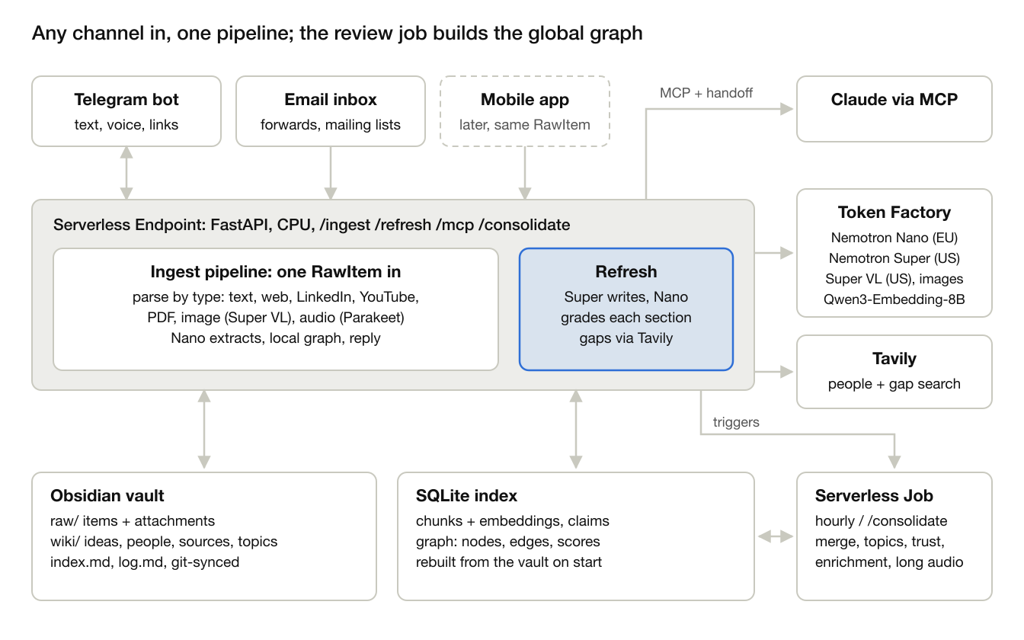
architecture · any channel, one ingest pipeline, one review job, vault + index
Telegram and email feed the endpoint today and a mobile app can later; every channel produces one RawItem. Ingest writes the vault and the index; people enrichment runs in the review job. The refresher reads them on demand through structured tools rather than raw search, and Claude pulls strings through the MCP endpoint. The hourly review job merges duplicate people and ideas, reruns relation checks, clusters topics, runs Tavily enrichment and recomputes trust. Freshness itself is computed at query time.

Ingestion pipeline
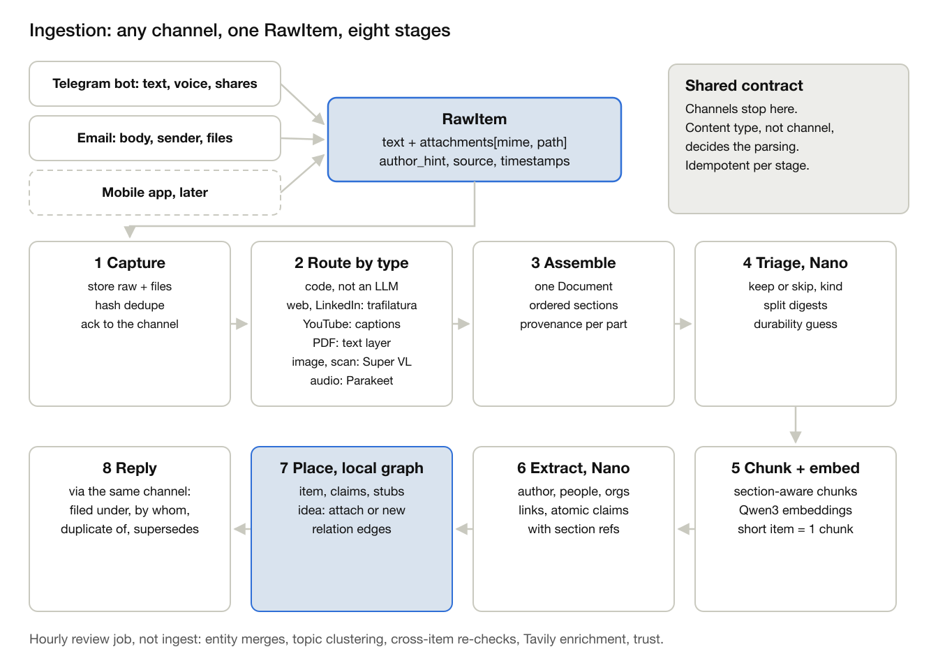
ingestion · any channel, one RawItem, eight stages
One interface. A channel adapter does only channel work: who sent it, who wrote it, which source, which files. The Telegram bot reads forward_origin, text, voice notes, files and links; email reads the body, the original sender of a forward, List-Id and attachments; a mobile app later posts the same RawItem to /ingest. Content types are not tied to a channel: a voice note, a YouTube link or a PDF is parsed the same way whichever channel brought it.
1. Capture. Store the raw item and its files in raw/, dedupe by content hash and message id, and ack to the channel. The webhook returns here; stages 2 to 8 run in a background task.
2. Route by type. Plain code on MIME type and URL pattern, not a model.
- Text and HTML: trafilatura.
- A link in the message: fetch the article. L
- inkedIn link: public articles (linkedin.com/pulse) carry schema.org Article JSON-LD with the author's name and profile URL, the publish date and the headline; the body comes from trafilatura. Posts (/posts/, /feed/update/) usually redirect to the login wall, so they go to Tavily extract, and if that fails the bot asks for the post text or a screenshot (Super VL reads it). We never log in to LinkedIn with a scraper account.
- PDF: PyMuPDF text layer per page. Images, and PDF pages without a text layer: Nemotron Super VL for OCR and a caption. Audio (voice notes): Parakeet transcription.
- YouTube link: the published captions, or the audio through Parakeet when there are none.
3. Assemble. Gather every part back into one Document: ordered sections, each with provenance (email body, attachment page 3, image 2). An email with three attachments is one item, not four. A linked article, LinkedIn share or YouTube video becomes its own child item with its own author and source (the writer, the LinkedIn profile, the YouTube channel), linked to the forward that shared it. A voice note is the sender's own thought: author is the user.
4. Triage, Nano. The one decision model before extraction: keep or skip, kind (post, article, newsletter digest, announcement), durability guess, and whether to split a digest of ten stories into ten items.
5. Chunk and embed. Section-aware chunks of a few hundred tokens with Qwen3 embeddings, for retrieval of passages. A short Telegram post is one chunk.
6. Extract, Nano. Author (taken from metadata when the page has it, as on LinkedIn, so Nano only fills gaps), mentioned people and organisations, links and atomic claims, each claim pointing to its section. Nano's 262K context takes most documents whole; longer ones go per section.
7. Place, local graph. Write the Item, Claims, Person and Source stubs, attach each claim to an idea or open a provisional one, and run the relation check against near neighbours.
8. Reply through the channel that brought the item: filed under, by whom, duplicate of, supersedes.
Decision models in between. Routing is deterministic; a router model adds cost and failure modes for a choice the MIME type already makes. Models decide only content questions: Super VL reads pixels, Parakeet turns speech into text, Nano triages and extracts. Every stage writes its status on the item, so a crash resumes from the last stage and a re-run is safe. Large PDFs and audio longer than a few minutes go to the Serverless Job instead of the endpoint.
Graph builder in two halves. Ingest builds the local graph for one item at step 7, which is what makes the reply possible. The hourly review job builds the global graph: entity merges, topic clustering, re-checks across items, enrichment and trust. Details in Graph structure and Ingest vs. hourly review.

Knowledge model and scoring
Three layers, following the three-graph architecture from the Amazon presentation Olga photographed.
Layer | Node | Fields | Lives in
Lexical, immutable | Item: one captured thing | channel, source, captured_at, published_at, url, kind (post, article, video, voice, thought), raw text | raw/
Subject, LLM-interpreted | Claim: one atomic statement | kind (fact, announcement, opinion, how-to, principle), durability class, half-life days, confidence, model version, valid_at, invalid_at, created_at, expired_at, superseded_by | SQLite index, mirrored in frontmatter
Subject, LLM-interpreted | Idea: a shared idea or thread grouping claims across items | title, summary, topics, first_seen, last_touched, claim ids | wiki/ideas/
Domain, curated | Person: author behind a channel, newsletter or article | role, affiliation, domains, channels, trust, trust rationale, profile sources | wiki/people/
Domain, curated | Source: channel, newsletter, site | owner person, reliability | wiki/sources/
Domain, curated | Topic: hub note | linked ideas, people, latest refresher | wiki/topics/
Edges, stored in a SQLite table and mirrored as wikilinks: SUPERSEDES, CONTRADICTS, DUPLICATES, ELABORATES, SUPPORTS, PART_OF idea, ABOUT topic, MENTIONS entity, AUTHORED_BY person, PUBLISHED_IN source. Every SUPERSEDES, CONTRADICTS and DUPLICATES edge carries a one-sentence rationale written by Nano at ingest, so any edge can be audited.
Scoring is deterministic and unit-tested; the models only supply the inputs.
- Durability class sets the base half-life: foundation 720 days, reference 180, news 30, ephemeral 7. Nano assigns the class with a rubric; the user can override from chat.
- Freshness decays as 2 to the power of minus elapsed days over half-life. An independent confirmation resets the clock and extends the half-life by 1.5 times, capped at the foundation value. A superseded claim keeps its chain but ranks at zero.
- Noise: members of a duplicate cluster beyond the first independent source, and ephemeral claims unconfirmed after two half-lives. Collapsed in refreshers with a count.
- Trust per person or source, 0 to 1, starts at 0.5. A learned part moves with confirmations versus supersessions or contradictions inside the half-life, and with user thumbs up or down. A profile part comes from Tavily enrichment: affiliation, first-hand versus repost, publication record, judged by Super with the rationale stored. The refresher shows both parts and why.
The relation check runs pairwise on the top neighbours by embedding and shared entities. Nano returns the relation, which claim is newer in event time rather than capture time, and the rationale.

Graph structure
Shallow and typed. The graph lives in SQLite as a nodes table and an edges table; the Obsidian vault and the Miro board are views exported from it. No Neo4j.
Node | What it is | Created by
Item | One raw captured thing: Telegram message, email, article. Never changed. | Ingest
Claim | One atomic statement from an item, with kind, durability class, half-life and the bi-temporal fields | Ingest
Idea | Claims that say the same thing or form one thread across items | Ingest (provisional), review (merge and split)
Topic | A hub. At most two levels: topic and subtopic. No deep taxonomy. | Review only
Person | Author or mentioned person: name, handles, affiliation, domains, trust with rationale, enrichment_status | Ingest (stub), review (enrichment)
Source | Telegram channel, newsletter or mailing list (List-Id), site | Ingest
Person to Topic expertise (EXPERT_IN) is derived from authored claims, never extracted. Where a new item lands:
1. Nano extracts the claims.
2. Each claim is embedded and compared with its top-k nearest claims, boosted by shared entities.
3. Nano attaches the claim to an existing idea or creates a new provisional idea.
4. The relation check against those neighbours returns SUPERSEDES, DUPLICATES, CONTRADICTS or unrelated, with a one-sentence rationale.
5. The idea links to an existing topic if one is close enough, otherwise it stays unsorted. Ingest never creates topics: one message is not enough evidence for a hub.
Rules that keep the graph clean: claim-to-claim edges only between near neighbours, topics only from clusters, precision over recall (when unsure, unrelated).

Ingest vs. hourly review
Both are needed, with different jobs: ingest works on one item at a time, review works across the whole corpus.
- Ingest: per item, synchronous, Nano only, safe to re-run. Stores the raw item, creates author and mention stubs with enrichment_status pending, places the claims, writes relation edges and replies in the bot: filed under, by whom, duplicate of, supersedes.
- Review job: hourly, or triggered by /consolidate in the demo. Batch and global, may use Super. Reruns relation checks where the neighbourhood changed (a correction can arrive before the original), merges duplicate people and ideas, clusters unsorted ideas into topics, works through the Tavily enrichment queue (3 searches per person), recomputes trust and marks noise. Decay needs no job: freshness comes from timestamps at query time.
Why not let ingest only store items and the agent do the rest: the bot can't reply with a filing verdict, new items wait up to an hour, and the demo loses its live moment. Why not let ingest do everything: results depend on arrival order, people get duplicated, and Tavily latency blocks the bot.
Scheduling: Serverless Jobs have no built-in cron, so the endpoint fires the job when the last consolidation is more than an hour old, or an external cron calls /consolidate.

Verified platform facts
Checked 15 October 2026 against the Token Factory model catalog and Nebius Serverless AI docs. Regions differ per model, so each tier gets its own base URL in config.
Need | Choice | Note
Fast calls: classify, extract, relate, grade | nvidia/NVIDIA-Nemotron-3-Nano-30B-A3B, eu-north1, 262K context | Alternative in the same region: nvidia/Nemotron-3_5-Lightning, 1024K
Reasoning: refresher synthesis, conflict adjudication, people profiling, gap planning | nvidia/nemotron-3-super-120b-a12b, us-central1, 256K | Ultra (550B) exists; likely unnecessary
Embeddings | Qwen/Qwen3-Embedding-8B, eu-north1 | The only embedding model hosted; the rules need at least one NVIDIA model, which Nano and Super satisfy
Reranker | None hosted | Nano acts as grader
Images and scanned PDF pages | nvidia/Nemotron-3.5-Super-VL, us-north1 | Checked 18 October 2026
Speech: voice notes, YouTube without captions | nvidia/parakeet-tdt-0.6b-v3, run by us: CPU on the endpoint for short notes, GPU Serverless Job for long audio | Token Factory hosts no speech model. CC BY 4.0, 25 European languages including Russian and Ukrainian; checked 18 October 2026
API | OpenAI-compatible at api.tokenfactory.nebius.com/v1; langchain-nebius offers ChatNebius with tool calling and structured output | A third-party report needed a us-central1 host for US models. Verify both tiers on day 1
Serving | Serverless AI Endpoint on a CPU platform | nebius ai create --type endpoint with image, container port, env and env-secret; managed HTTPS URL
Background work | Serverless AI Job | nebius ai create --type job; REST POST to api.nebius.cloud/ai/v1/jobs; no built-in scheduler found, so the endpoint triggers it
Web research | Tavily search with topic and time_range, and extract | Credits through the Nebius Builders Program
Chat front | Own Telegram bot with aiogram; email through a dedicated inbox over IMAP | Hermes Agent gateway dropped on 18 October
Credits | Devpost activation code NEBIUS-DEVPOST-GLOBAL26 for $25 Token Factory; Builders Program adds Token Factory and Tavily credits | Devpost resources page

Team split
Three owners and one open workstream. Kirill owns the architecture and the schemas, email ingestion and the knowledge half-life, Olga owns ingestion, Victor owns the graphs, the Miro visualization and the people profiles. Retrieval has no owner yet and is decided at the next sync; the platform work goes with it. Availability from the chat: Kirill works this weekend and Monday, travels three days mid next week, full time from the end of next week; Olga starts Monday 19 October at half days; Victor to confirm.
Owner | Workstream | Deliverables | Hands off to
Olga | Ingestion: channel adapters (Telegram bot now, mobile app later) and content parsers for articles, LinkedIn shares, YouTube, voice notes, PDFs and images; claim extraction and placement in the graph; seed corpus and eval | channels/telegram.py, engine/parse/ (web, linkedin, youtube, pdf, image, audio), engine/extract.py, engine/relate.py, eval/seed_corpus/, eval/test_relate.py | Kirill: seed corpus by day 4 so scoring has real data. Victor: Person stubs with enrichment_status from ingest
Kirill | Architecture and schemas: ARCHITECTURE.md, pydantic schemas including RawItem and the node and edge enums. Email ingestion and knowledge half-life: dedicated inbox polled over IMAP, forwards and mailing-list subscriptions, durability classes, freshness, confirmation reset | ARCHITECTURE.md, refresher/schemas.py, channels/email.py, engine/scoring.py with unit tests | Olga and Victor: schemas, RawItem and graph enums by day 2. Retrieval owner: freshness function and durability classes by day 5
Victor | Graphs, Miro visualization, people profiles: nodes and edges tables, hourly review job, Tavily enrichment, trust | store/graph.py, engine/consolidate.py, engine/people.py, viz/miro.py | Retrieval owner: graph tables populated by day 5
Open | Retrieval and platform: refresher, structured retrieval tools, MCP endpoint, Dockerfile, Serverless Endpoint and Job, demo page, video | graphs/refresh.py, tools/, deploy/, api/app.py, video | Owner decided at the next sync
Interfaces that must be agreed on day 1 and not changed after:
- The pydantic schemas in refresher/schemas.py. Everyone builds against them.
- The vault layout: raw/, wiki/ideas, wiki/people, wiki/sources, wiki/topics, wiki/refreshers, index.md, log.md. Frontmatter keys fixed in store/vault.py.
- The HTTP contract: /ingest takes an item, /refresh takes a topic, /feedback takes a claim or person id and a vote, /health returns model ids and last consolidation time.
- The RawItem schema that every ingestion channel produces, Telegram, email or a future mobile app: channel, source_id, source_name, author_hint (name, handle, email, url), captured_at, published_at, url, kind, text, attachments (mime, path).
- The graph tables (nodes, edges) in store/graph.py and the node and edge enums in refresher/schemas.py. Ingest writes them, retrieval and the Miro export read them.
Shared across the team: README feedback section, filled whenever anyone hits a platform issue. Daily 15-minute sync in the chat; a call this weekend to confirm the split.

Timeline
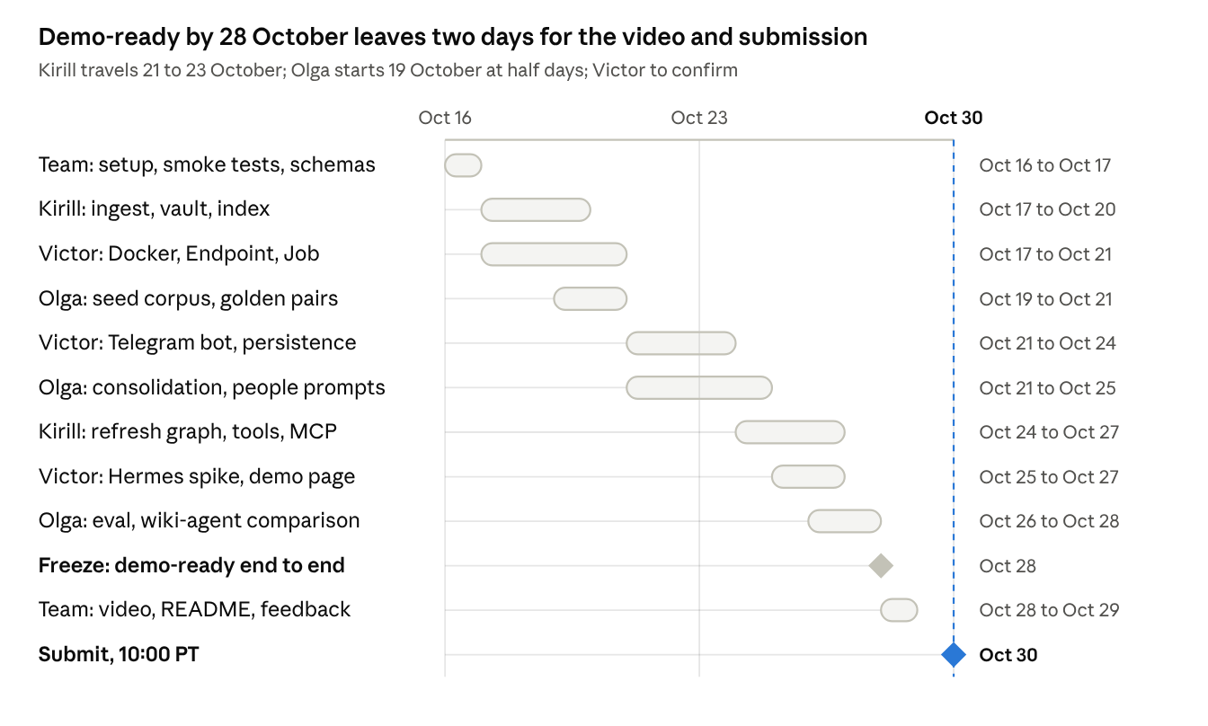
timeline · 16 to 30 October 2026, one row per workstream
Three lanes run in parallel from 17 October and meet at the freeze on 28 October. Done looks like this at each gate: day 1, Nano and Super answer structured calls and the schemas are agreed; day 5, a forwarded message lands in the deployed vault with a relation edge; day 10, a refresher cites ideas, people and a Tavily-found read; day 13, the eval table and README are in; day 15, the video is public and the Devpost form is submitted.

Demo script and submission checklist
The video must show triage, people and strings, not just organised notes, or it looks like the wiki pattern with timestamps. Under three minutes.
- Forward three Telegram messages on one topic: an original announcement, a repost from another channel, and a later correction. Show the bot replies: filed under, by whom, duplicate of, supersedes.
- Open the vault in Obsidian. Show the raw items, the idea note with its string back to them, and the graph view.
- Run /refresh on the topic. Show the refresher: ideas, current versus foundation, collapsed noise with a count, conflicts.
- Show the experts graph: three people, their domains, trust with rationale, one enriched from Tavily.
- Show a gap the refresher found and the article Tavily returned for it.
- Open the dig-deeper pack in Claude and ask one follow-up that pulls a string through MCP.

Submission
Submission, all due before Friday 30 October 2026, 10:00 PT:
- ☐ Public repository with Apache-2.0 license visible at the top of the page
- ☐ README with setup, run instructions, how Nemotron, Token Factory, Serverless and Tavily are used
- ☐ Working demo URL: the Serverless Endpoint with /health and the read-only experts graph page
- ☐ YouTube video, public, under three minutes, no third-party music
- ☐ Project description: what, why, how it works
- ☐ Track: Personal AI
- ☐ Feedback on Token Factory, AI Cloud and NVIDIA models
- ☐ City selected if anyone attended a Builders and Brews event
- ☐ English for all materials

Risks and fallbacks
Risk | Fallback
Nemotron structured output or tool calling is flaky through Token Factory | JSON-mode prompting with pydantic validation and one retry; keep any non-NVIDIA fallback out of the demo
Cross-region errors between Nano in the EU and Super in the US | One base URL per tier in config; verify on day 1
People enrichment is wrong or feels intrusive | Only public professional fields for authors of channels, newsletters and articles; never enrich private individuals from personal chats; sources shown; person notes editable
Scanned PDFs and images need the US-region vision model | Text layer first; Super VL only for pages without text; on failure keep the raw file and skip it
YouTube blocks caption fetches from cloud IPs | Download the audio and transcribe with Parakeet; the user can also forward the transcript as text
LinkedIn posts sit behind the login wall, and LinkedIn may block cloud IPs | Public articles via JSON-LD; posts via Tavily extract; otherwise the user forwards the post text or a screenshot. No logged-in scraping
Serverless Endpoint disk is ephemeral | Vault in a git repository pushed after each write, or Nebius object storage; the SQLite index rebuilds from the vault on start
Judges read it as Karpathy's wiki with timestamps | The side-by-side eval on the seed corpus and a demo that shows dedup, supersession, people and strings
Graph quality: the Qdrant and Neo4j warning from the chat | Typed edges, few of them, each with rationale; accept unrelated generously; show precision over recall
Credits run out | Nano for every ingest call; Super only for refreshers and profiles; Tavily budget of 3 searches per person and 6 per refresher

